Why Join Rotary?
With over 150 members, the Rotary Club of Fort Collins has been taking action to serve our local and global community since 1918. We have many alternatives for you to get involved, but our members find the following information most helpful generally. Read below to learn about Rotary Club of Fort Collins.
- Enjoy Professional Networking, Friendship and Fellowship:
  - A founding principal of Rotary was to meet periodically to enjoy comradery and enlarge one’s circle of business and professional acquaintances. As the oldest service club in the world, rotary club members represent a cross-section of the community’s owners, executives, managers, political leaders, and professionals—people who make decisions and influence policy.
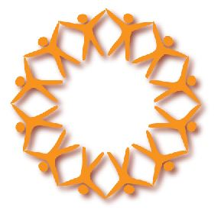
  - Rotary’s classification system ensures that a club’s memberships represents a variety of the community’s professional men and women, including leaders in business, industry, the arts, government, sports, the military, and religion.
  - Rotary clubs are nonpolitical, nonreligious, and open to all cultures, races, and creeds.
  - Fellowship is a major attraction of membership even today. Club members enjoy meeting with like-minded professionals, and club projects offer additional opportunities to develop enduring friendships. Rotary members have opportunities to travel and develop friendly contacts in almost every city in the world.
  - Weekly Rotary club programs keep members informed about what is taking place in the community, nation, and world and motivated to make a difference.

- Get Involved in Local Community Service
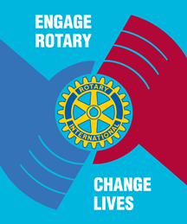
  - Club members have many opportunities for humanitarian service. Service programs address concerns such as:
    - Health care
    - Hunger
    - Poverty
    - Illiteracy
    - Environmental concerns
    - And many others
  - Rotarians experience the fulfillment that comes from giving back to the community.
  - For a list of projects the Rotary Club of Fort Collins has been involved in, and to find out more about how to suggest your own project, go to our website: http://rotarycluboffortcollins.org/Page/local-community-service#sthash.xCH56n9c.dpuf

- Experience International Awareness and Service
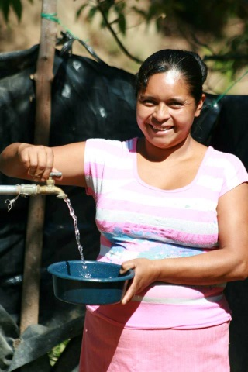
  - Rotary has more than 32,000 clubs in over 200 countries and geographical areas.
  - Rotarians can gain an understanding of humanitarian issues through international service projects and exchange programs. One of Rotary’s highest objectives is to build goodwill and peace throughout the world.
  - The Rotary Club of Fort Collins has been active in numerous international projects, including:
    - Health projects
    - Water projects
    - Education projects
    - Dengue Fever
    - Habitat Homes
  - For a list of other international projects visit: http://rotarycluboffortcollins.org/Page/international-awareness-and-service#sthash.v9rMJNqi.dpuf

- Share Your Time and Experience With Youth Through New Generations
  - Rotary sponsors some of the world’s largest youth exchange, educational exchange, and scholarship programs. Rotary clubs provide innovative training opportunities and mentoring for young leaders and involve family members in a wide range of social and service activities.
  - The Rotary Club of Fort Collins works with the collegiate branch of rotary international through RotorAct at Colorado State University.
  - Rotary is also involved in a number of scholarship programs supporting our youth, including:
    - Rotary Club of Fort Collins Scholarships
    - Rotary Youth Leadership Awards
    - Ethics Scholarship Award
    - Peace Fellowships
  - See more at: http://rotarycluboffortcollins.org/Page/new-generations#sthash.eg7SYIep.dpuf

- Stay Informed With Exciting Weekly Programs and Speakers
  - The Wednesday noon meeting features a speaker, special presentation or event.
  - The Satellite group meets at alternative times with changing meeting formats.
  - The Rotary Club of Fort Collins strives to have the best speakers ranging from community leaders in politics, business, government, education and community service.
  - We cover a diverse range of topics, both highly educational and highly entertaining.
  - We use the RITE formula for selection of speakers (relevant, informative, timely, and entertaining).
  - Go online for a list of past programs to give you an idea of the exciting range of presentations: http://rotarycluboffortcollins.org/page/speakers#sthash.dujoj7ts.dpuf

New Membership Message From Rotary International
Rotary is a community of friends who are committed to creating positive change in the world. Find out how joining your local club can enrich your life and improve the lives of people living in your neighborhood and across the globe.

"I joined to have a stronger connection to the community. I love that I'm sitting next to the former police chief, the owner of the cutest shop in town, and my neighbor's dentist, and we're all listening to a presentation from the mayor."

What Is Rotary?
Rotary brings together community leaders from all continents, cultures, and occupations to share their ideas for making the world a better place. By combining their distinct skills and expertise, Rotary members are tackling some of the world's most pressing problems – from local initiatives like feeding the hungry to global efforts like eradicating polio.

It all begins at the weekly club meeting, where members catch up with friends, hear what's happening in their community, and organize club activities and service projects. It's a fun way to connect with the people in your community who share your passion for doing good.

Why Should I Join a Rotary Club?
"My favorite thing about Rotary is that it's an efficient use of my time. All at once, I'm creating new friendships, making new business contacts, learning how my community works, and participating in the world."

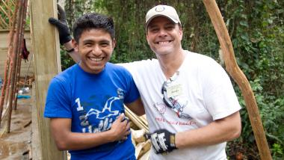
You'll make valuable connections with community leaders who care about the issues facing your hometown and hometowns around the world. And you'll have the chance to apply your personal experience and professional skills to solve these challenges and create positive change.

As a member, you'll find opportunities to network and develop your professional skills. You can take the lead in developing projects, organizing events, and running your club. Through these activities, you'll hone your project planning skills, improve your public speaking, and even learn new skills, like public relations, social media, and fundraising.

You'll spend time with friends and make new ones every week! Make it a family affair. Members are encouraged to invite their spouse or partner, children, and parents to help with service projects and attend club events. Rotary offers opportunities for all ages, from service clubs for youth and young adults (Interact and Rotaract) to exchanges that give young and old alike the chance to explore new cultures.

